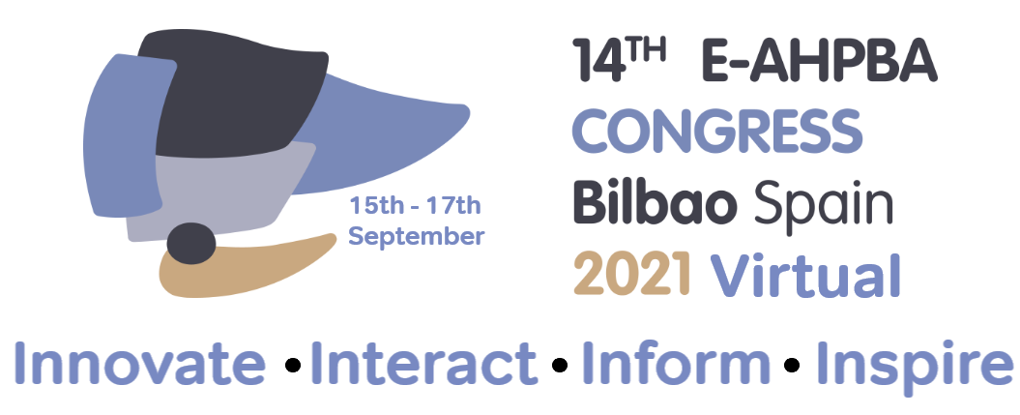
Today, the E-AHPBA has decided that the E-AHPBA 2021 Biennial Congress will be a fully virtual meeting from 15th-17th September 2021.
Your safety is the E-AHPBA’s first priority and it goes without saying that we strictly follow all decisions and recommendations by authorities and governments. With this in mind, E-AHPBA 2021 Bilbao will be an entirely online event. As you cannot come to Bilbao, we will bring it to you!
The Local Organising Committee in Bilbao will be the Congress hosts and the Spanish flavour will be felt throughout. The theme for the E-AHPBA 2021 Biennial Congress is FOCUS ON INNOVATION and an outstanding scientific programme that combines current evidence and state of the art technology is being prepared.
The Bilbao Congress will provide an exciting and INTERACTIVE experience and will include leading keynote speakers, engaging breakout sessions, meet the professor opportunities, exclusive product updates from industry, and much, much more. Best of all, plenaries and breakout sessions will be easily accessible on-demand for conference attendees to view at their own convenience. It really is an invaluable opportunity to become INFORMED about the latest updates from the HPB Community and a chance to educate and INSPIRE yourself, we look forward to having you join us!
INNOVATE INTERACT INFORM INSPIRE
We want to make sure that we provide the best opportunity for you to present you work and have therefore decided to EXTEND the abstract submission deadline until Tuesday 9th March 2021.
There will be opportunity for you to present in a manner of ways from, live oral, poster and video presentations. In addition, there will be a chance for posters to be awarded a short oral in a quickfire poster session with live discussion. Click here for further information on abstract submission and guidelines and should you have any queries please contact the E-AHPBA 2021 Abstract Team eahpba2021.scientific@eahpba.org.

